

DUY TAN UNIVERSITY
---o0o---
INFORMATION SYSTEM
THEORIES & PRACTICES
REPORT
Odoo for Consulting Service Company
Instructor: MSc. Nguyen Trung Thuan
Class: CMU-IS 251 BIS Year: 2026
Group: group 2
Members: 1. Duc, Nguyen Nhu Minh - 30219263424
2. Hai, Huynh Thi - 30205127541
3. Linh, Nguyen Thi Thuy - 30205149111
4. Ly, Tran Thi Khanh - 30204629937
5. Trinh, Nguyen Phuong Kieu - 30206249603

Implementation Period: 23/03/2026 to 08/05/2026

DUY TAN UNIVERSITY
---o0o---
REPORT
Course: Information System Theories & Practices
Odoo for Consulting Service Company
List of Team Members
Full Name | MSSV | Class | Roles | Result
Duc, Nguyen Nhu Minh | 30219263424 | CMU-IS 251 BIS | Team leader  Email:ducnguyennhu2006@gmail.com | 100%
Hai, Huynh Thi | 30205127541 | CMU-IS 251 BIS | Member | 100%
Linh, Nguyen Thi Thuy | 30205149111 | CMU-IS 251 BIS | Member | 100%
Ly, Tran Thi Khanh | 30204629937 | CMU-IS 251 BIS | Member | 100%
Trinh, Nguyen Phuong Kieu | 30206249603 | CMU-IS 251 BIS | Member | 100%

Table of Contents
INTRODUCTION 1
I. PROJECT OVERVIEW 2
1.1 Rationale for Topic Selection 2
1.2. Project Objectives 3
II. BUSINESS ANALYSIS AND SOLUTION SELECTION 3
2.1. Business Model Selection 3
2.2. Analysis of Current Information System 4
2.3. Proposed Odoo Modules 5
2.3.1. Module CRM 6
2.3.2. Module Sales 6
2.3.3. Module Project 6
2.3.4. Module Timesheet 7
2.3.5. Module Accounting 7
2.3.6. Process Integration Between Modules 7
2.4. System Architecture Design 8
2.4.1. Hardware Architecture 8
2.4.2. Software Architecture 8
2.4.3. Data Architecture 9
2.4.4. Security Architecture 9
2.4.5. New Technology Integration 10
2.4.6 Conclusion 10
III. DEPLOYMENT AND INSTALLATION ON ODOO 12
3.1. System Demo Video 12
3.2. Odoo Account with Sample Data 12
3.2.1. Functions and Roles of Each System 12
3.2.2. Sample Data in the System 12
3.2.3. Data Integration and Consistency 12
3.3. Basic User Guide Document 12
3.3.1. Introduction 13
3.3.2. System Overview 13
3.3.3. CRM Module 13
3.3.4. Sales Module 13
3.3.5. Project Module 14
3.3.6. Timesheet Module 14
3.3.7. Accounting Module 14
3.3.8. Integrated Workflow Explanation 15
3.3.9. Key Benefits 16
3.3.10. Conclusion 16
3.4. Detailed Business Process Flow Diagram 17
IV. DATA ANALYSIS AND MANAGEMENT REPORTING 19
4.1. Dashboard Design 19
4.1.1. Executive Dashboard 19
4.1.2. Department Manager Dashboard 20
4.1.3. Operations/Project Management Dashboard 21
4.2. List of Key Reports 22
4.2.1. Invoice Analysis Report 22
4.2.2. Project Profitability Report 23
4.2.3. Employee Timesheet Report 24
4.2.4. Revenue Forecast Report 25
4.2.5. Overdue Receivables Report 26
4.3. Data Analysis and Recommendations 26
4.3.1. Actual Data Analysis (April 2026) 26
4.3.2. Identification of Key Issues 27
4.3.3. Proposed Improvement Solutions 27
V. EVALUATION AND RECOMMENDATIONS 28
5.1. System Evaluation 28
5.1.1. SWOT Analysis of the Odoo Solution for Service and Consulting Companies 28
5.1.2. Comparison Between Odoo and Another ERP Solution 29
5.1.3. Cost–Benefit Analysis (Estimated) 29
5.1.4. Evaluation of Information Integration Efficiency 30
5.2. Development Recommendations 30
5.2.1. Implementation Roadmap in Three Phases 30
5.2.2. Risk Management and Future Expansion Architecture 30
5.3. Lessons Learned 31
5.3.1. The Role of MIS and Expert Skills in Digital Transformation 31
5.3.2. Lessons on Integration and System Sustainability 31
CONCLUSION 32
REFERENCES 33

TABLE OF FIGURES
Figure 1. Task assignment and role responsibilities 2
Figure 2. Current Workflow and System 5
Figure 3. Proposed Odoo ERP Integrated Workflow 8
Figure 4. Odoo ERP System Architecture and Integration Framework 11
Figure 5. Odoo Modules (Models) For A Consulting Service Company 13
Figure 6. Integrated Business Process Workflow Using Odoo ERP 17
Figure 7. Executive Financial Health Dashboard 19
Figure 8. Executive Financial Health Dashboard 20
Figure 11. Invoice Analysis Report 22
Figure 12. Project Profitability Report 23
Figure 13. Employee Timesheet Report 24
Figure 14. Revenue Forecast Report 25
Figure 15. Overdue Receivables Report 26

INTRODUCTION
In today’s digital economy, the adoption of Enterprise Resource Planning (ERP) systems is no longer an optional choice but has become a critical requirement for businesses seeking to enhance their competitiveness and operational efficiency. For service and consulting firms, where core value is primarily derived from knowledge, expertise, and the effective utilization of human resources, it is essential to closely manage and control processes from the initial stage of customer engagement through to project completion and delivery.
However, many organizations continue to face significant challenges due to fragmented data systems and the reliance on manual processes. These limitations not only hinder information flow across departments but also lead to resource inefficiencies, increased operational risks, and reduced overall management effectiveness. Such issues highlight the urgent need for an integrated management solution that can streamline operations and ensure data consistency.
Recognizing this importance, our team has undertaken the project titled: “Implementing an Odoo ERP Solution for a Consulting Services Company.” The objective of this project is to explore and demonstrate how a comprehensive ERP system can address existing operational challenges and improve organizational performance.
This project does not merely focus on software installation and configuration, but also emphasizes in-depth business process analysis, process re-engineering, and the development of intelligent management reporting systems. By leveraging the capabilities of the Odoo platform, our team aims to provide a holistic perspective on how technology can optimize workflows, enhance data transparency, improve decision-making capabilities, and ultimately create a solid foundation for sustainable business growth in the future.

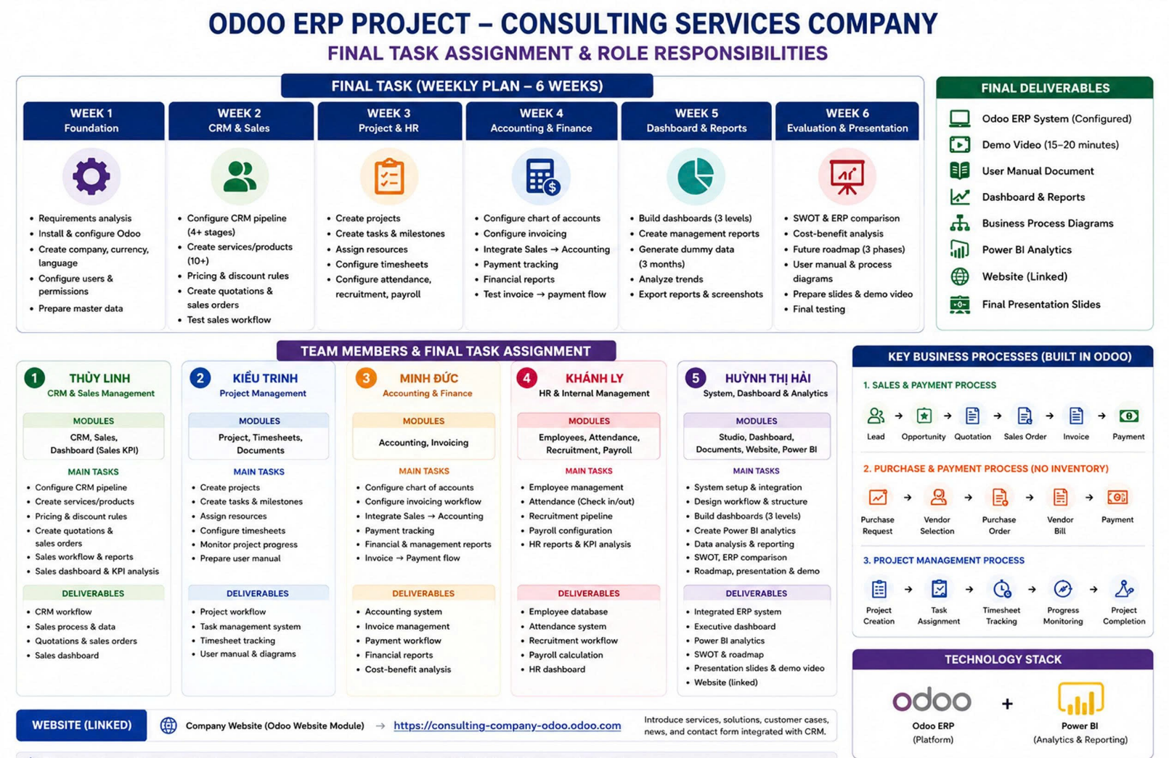
I. PROJECT OVERVIEW
Figure 1. Task assignment and role responsibilities

1.1 Rationale for Topic Selection
In the context of the Fourth Industrial Revolution and the rapid pace of digital transformation in Vietnam, service and consulting companies are facing numerous challenges in managing their business operations. Typical issues include:
- Decentralized project management with a lack of real-time progress tracking.
- Difficulties in accurately recording working time (timesheets), leading to loss of billable hours and billing inaccuracies.
- Disconnected processes between sales, project initiation, and invoicing, causing cash flow delays and poor profit control.
- Ineffective Customer Relationship Management (CRM) with a lack of centralized data.
- High operational costs due to the use of multiple standalone and non-integrated software systems.
Odoo is a modern open-source ERP platform with a highly modular and fully integrated architecture, making it particularly suitable for service and consulting businesses. It enables the establishment of a unified management system and automates processes ranging from sales and project management to timesheets, accounting, and reporting.
The rationale for selecting this topic is based on:
- The high practical demand of service companies in Vietnam, especially in Da Nang – a rapidly developing hub for services and technology.
- The relevance of digital transformation in the service sector, where core value lies in people and project execution.
- The flexibility, reasonable cost, and strong community support of the Odoo platform.
- The opportunity to apply knowledge of ERP systems, project management, and programming to real-world business problems.

1.2. Project Objectives
Overall Objective:
To design and implement an Odoo ERP solution for a service and consulting company to optimize management processes, improve operational efficiency, enhance profit control, and support data-driven decision-making based on real-time information.
Specific Objectives:
- Integrate core modules: CRM, Sales, Projects, Timesheets, Accounting, Planning, and Helpdesk (if required).
- Automate the end-to-end process: from lead → contract → project → timesheet → invoicing → payment and project profitability tracking.
- Accurately monitor project progress, resource utilization rates, and employee productivity, while minimizing non-billable time.
- Develop real-time dashboards for reporting revenue, costs, and profit by project, customer, and employee.
- Propose a suitable implementation model, training plan, and necessary customizations for Vietnamese businesses (e-invoicing, tax reporting, etc.).
- Evaluate implementation effectiveness (ROI) and propose future system expansion directions.
This project does not only focus on software installation but also emphasizes Business Process Reengineering (BPR) based on Odoo best practices in the service industry.

II. BUSINESS ANALYSIS AND SOLUTION SELECTION

2.1. Business Model Selection
Basic Information:
- Full name: Nova Consulting Business Consulting and Solutions Company Limited.
- Founded: 2026
- Main office: Da Nang City, Vietnam.
- Business: Management consulting, digital transformation, and technology solution implementation.
- Hotline: 02471066866
- Target customers: Small and medium enterprises (SMEs).
- Business model: B2B
- Scale: approximately 55 employees
Business Activities:
- Providing services through:
Projects
Long-term consulting contracts
- Main operating channels:
Website
Social platforms
Core Values:
Highly specialized consulting team.
Effective project implementation capability.
Organizational structure:
-Board of Directors: 2 members (strategic orientation and overall management).
-Sales Department: 10 staff (customer acquisition, contract management).
-Consulting & Implementation Department: 20 staff (project execution).
-Project Management Department: 8 staff (progress tracking, quality control).
-Customer Service Department: 7 staff (support and customer relationship maintenance).
-Accounting & Human Resources Department: 8 staff (finance and HR management).
Current Issues:
Although the organizational structure has been clearly divided, the enterprise still faces many difficulties in coordinating information between departments.

2.2. Analysis of Current Information System
Currently, the company’s information system is not integrated but exists as multiple separate tools.
The Sales Department uses Excel to manage customers and sales opportunities. After signing contracts, information is transferred to the Consulting Department via email or attached files. The Consulting and Project Management Departments use tools such as Google Sheets or separate task management software to track progress. Employees record working time manually, which is not linked to the project management system. Meanwhile, the Accounting Department uses independent software to process invoices and financial reports.
The use of multiple separate systems leads to several major issues.
- Firstly, data is fragmented. Customer, project, and financial information are not stored centrally, making it difficult to consolidate and control.
- Secondly, there is a lack of connection between departments. Information is not updated in real time, leading to data inconsistencies and delays in task processing.
- Thirdly, workflows are disrupted. When transferring information between departments, data is often incomplete or inaccurate, affecting project progress.
- Fourthly, employee time management is inefficient. Without a centralized recording system, the company faces difficulties in evaluating performance and calculating costs.
- Fifthly, financial reconciliation is still manual. Data must be aggregated from multiple sources, which is time-consuming and prone to errors.
Regarding information needs, each management level has different requirements.
The Board of Directors needs aggregated reports on revenue, profit, and project performance to make strategic decisions.
Managers need to track project progress, allocate resources, and evaluate employee performance.
Employees need clear information about tasks, deadlines, and assigned responsibilities.
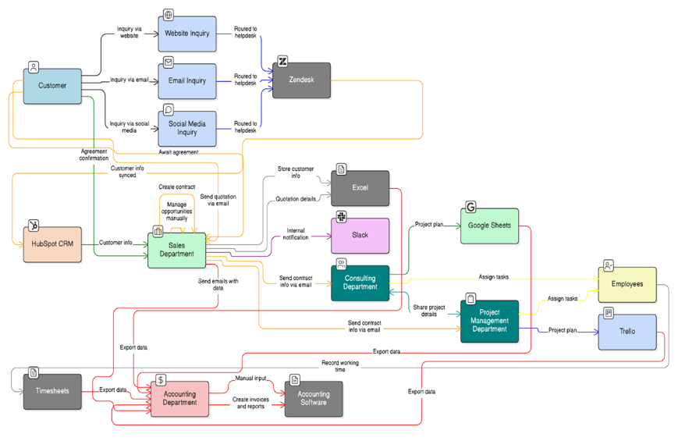
These requirements demand an integrated information system capable of providing real-time data.
Figure 2. Current Workflow and System

2.3. Proposed Odoo Modules
To overcome the limitations of the current system, Nova Consulting needs to implement core Odoo modules. The selection of these modules is not only based on functionality but is also closely tied to the actual problems existing within the enterprise. Each module plays a role in solving a specific group of problems while also being interconnected to form a unified management system.

2.3.1. Module CRM
In the current system, customer information is scattered across multiple Excel files and employees’ personal emails. This leads to inconsistent data, duplication, or data loss. In addition, the company lacks tools to track the customer journey from initial contact to contract signing. This makes it difficult for the sales department to control sales opportunities and may result in missing potential customers.
The CRM module allows all customer data to be centralized into a single system. This system supports managing the sales pipeline in clearly defined stages, helping employees easily track and update the status of each customer. In addition, CRM allows storing interaction history, helping the company better understand customer needs.
The implementation of CRM helps the company shift from manual management to systematic management. This not only improves customer control but also enhances sales efficiency. In the long term, CRM data also serves as a foundation for analyzing customer behavior and building appropriate business strategies.

2.3.2. Module Sales
The process of creating quotations and managing contracts is currently done manually, mainly through documents and emails. This is time-consuming and prone to errors during data entry. In addition, quotation and contract data are not directly linked to customer information, making it difficult to check and reconcile.
The Sales module allows creating quotations and contracts directly from CRM data. All information is automatically linked, reducing the need for re-entering data. In addition, the system supports managing quotation status, helping the company effectively track the progress of closing deals.
Using the Sales module helps standardize the sales process, reduce errors, and enhance professionalism when working with customers. At the same time, centralized data storage helps the company easily monitor revenue and business performance.

2.3.3. Module Project
Currently, consulting projects are managed using multiple tools such as Google Sheets or separate software. This results in unsynchronized information, making it difficult to track progress and control work quality. Managers also face difficulties in allocating resources and evaluating project status.
The Project module provides a centralized project management platform, allowing tasks to be broken down into specific activities, assigned to employees, and tracked in real time. The system also supports visualizing task status, making it easier for managers to control.
Implementing the Project module helps improve project management efficiency, ensuring progress and service quality. In addition, the system increases transparency, helping departments coordinate better.

2.3.4. Module Timesheet
Employee working time is currently not fully and accurately recorded. Recording is mainly manual and not linked to specific projects. This makes it difficult to evaluate performance and calculate project costs.
The Timesheet module allows employees to record working time directly in the system and link it to specific project tasks. This data is updated in real time and can be easily aggregated.
With Timesheet, the company can accurately determine the amount of time and resources used for each project. This not only helps evaluate employee performance but also supports accurate cost and profit calculation.

2.3.5. Module Accounting
Accounting activities currently depend on aggregating data from multiple sources such as Excel, email, and timesheets. This process is time-consuming and prone to errors. In addition, financial data is not updated in a timely manner, making decision-making difficult.
The Accounting module allows automation of financial operations such as invoicing, tracking receivables, and generating reports. When integrated with other modules, financial data is automatically updated without re-entry.
Implementing the Accounting module improves the accuracy of financial data and significantly reduces manual workload. At the same time, the company can monitor financial status in real time, enabling faster and more accurate decision-making.

2.3.6. Process Integration Between Modules
The above modules are connected into a unified process. The process starts from CRM, where customer information is stored. When the customer agrees, data is transferred to Sales to create quotations and contracts. After that, the system automatically creates a project in the Project module. Employees perform tasks and record working time in Timesheet. Finally, data is transferred to Accounting for financial processing.
The important point is that data only needs to be entered once but is used throughout the entire system. This helps reduce errors, save time, and improve management efficiency.

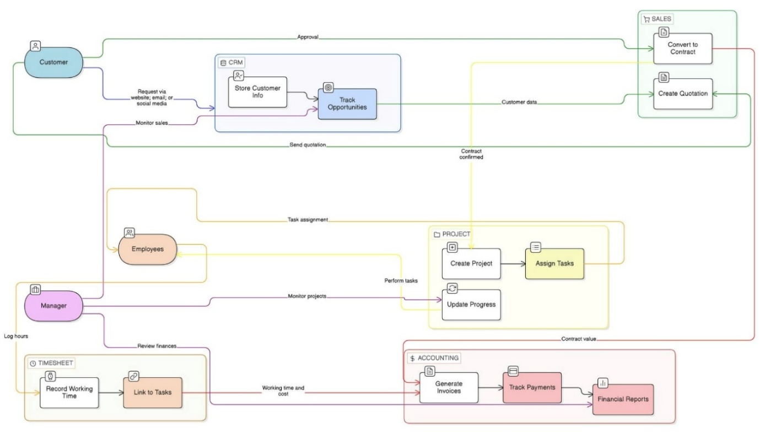
Figure 3. Proposed Odoo ERP Integrated Workflow

2.4. System Architecture Design
To address issues of data fragmentation, lack of interdepartmental integration, and to improve management efficiency, Nova Consulting proposes implementing an Odoo ERP system with an overall architecture consisting of five main components: hardware architecture, software architecture, data architecture, security architecture, and new technology integration.

2.4.1. Hardware Architecture
The system is built based on a cloud computing model to ensure scalability, flexibility, and optimization of initial investment costs.
Servers are deployed on platforms such as Odoo Online or Odoo.sh. The entire system is stored and operated in a cloud environment, so the company does not need to invest in on-premise physical servers.
The network infrastructure allows users to access the system via the Internet. Therefore, the company must ensure a stable connection and implement appropriate security measures such as HTTPS or VPN.
End-user devices include desktops or laptops for office staff, mobile devices for sales staff, and tablets for project management activities.
The system can scale flexibly as the number of users increases without changing physical infrastructure. Cloud-based hardware architecture is especially suitable for SMEs, supporting remote work and reducing initial investment costs.

2.4.2. Software Architecture
The software system is built on the Odoo ERP platform, integrating multiple modules to ensure seamless information flow across departments. Main modules include CRM for customer management, Sales for sales management, Project for project management, Timesheet for tracking working time, and Accounting for financial management.
The system operates in a linked chain from CRM to Sales, from Sales to Project, followed by Timesheet and finally Accounting. Data is entered once at the initial stage and used throughout the entire system.
The company can customize processes such as redesigning sales workflows, adjusting project management processes, building dashboards for each management level, and creating reports tailored to operational needs.
In addition, the system can integrate with external services such as corporate email or document storage platforms via API.
The software architecture ensures high integration, reduces manual operations, and enhances collaboration between departments.

2.4.3. Data Architecture
Data is organized in a centralized model to ensure consistency and support decision-making. The database management system used is PostgreSQL, which is the default platform of Odoo.
Main data entities include customers, sales opportunities,quotations/contracts, projects, tasks, timesheets, and invoices.
The data flow starts with entering customer information into the CRM system. Then, data is transferred to the Sales module to create quotations and contracts. Once the contract is signed, the system automatically creates a project in the Project module. Employees update progress and working time in Timesheet. Finally, data is transferred to the Accounting module for financial processing.
In the future, the company can build a data warehouse to support advanced analytics and management reporting. A centralized data architecture eliminates duplication, improves accuracy, and enhances information analysis efficiency.

2.4.4. Security Architecture
The system is designed to ensure information security through multiple layers of protection. User authentication is performed via personal accounts and can integrate single sign-on mechanisms.
Access rights are assigned based on roles and departments. Sales staff can access CRM and Sales. Project staff use Project and Timesheet. Accounting uses Accounting. System administrators have full access.
Data is protected using HTTPS protocol during transmission. Sensitive information is encrypted to ensure security. The system performs automatic daily backups and allows recovery in case of incidents. The security architecture ensures confidentiality, integrity, and availability of the information system.

2.4.5. New Technology Integration
To enhance operational efficiency and competitiveness, the system can integrate modern technologies. Cloud computing enables users to access the system anytime, anywhere and scale easily.
Artificial Intelligence and Machine Learning can be applied to analyze customer behavior and forecast revenue. Business Intelligence tools support building management dashboards and analyzing performance indicators in real time. Mobile applications allow employees to update data quickly and conveniently.
In the future, the company can integrate technologies such as IoT to monitor performance. Integrating new technologies makes the system more flexible and aligned with digital transformation trends.

2.4.6 Conclusion
The system architecture is designed toward full integration, centralized data, and high scalability, making it suitable for a consulting service business model like Nova Consulting.
The system not only helps solve current limitations but also creates a solid foundation for future digital transformation.
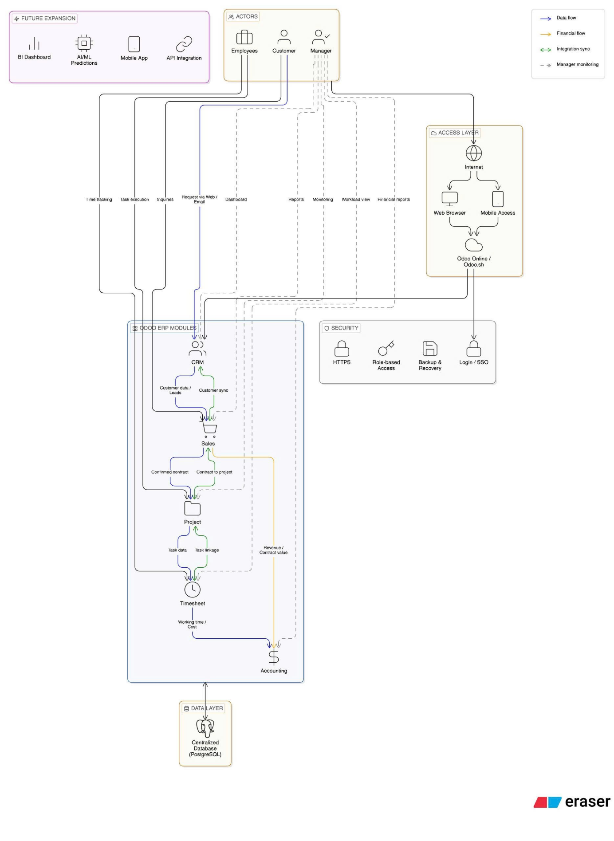
Figure 4. Odoo ERP System Architecture and Integration Framework

III. DEPLOYMENT AND INSTALLATION ON ODOO

3.1. System Demo Video

3.2. Odoo Account with Sample Data

3.2.1. Functions and Roles of Each System
The Odoo system is configured with user accounts to simulate the organizational structure of a software consulting services company. Clear role-based access control ensures that each department performs its designated functions effectively and enhances overall management efficiency.
Specifically, the system includes the following roles:
- Administrator: Has full access to the system and is responsible for configuring modules, setting up data, and managing users.
- Sales Staff: Responsible for managing customers, creating quotations, and tracking as well as processing sales orders.
- Accountant: Handles financial operations such as issuing invoices, monitoring receivables, and recording payments.
The division of roles ensures that the system operates according to standardized processes and closely reflects real-world business practices.

3.2.2. Sample Data in the System
To support demonstration and testing, the system is built with a set of sample data tailored to the software consulting services domain.
Specifically, it includes:
- Customers: A list of companies with complete basic contact information.
- Services: Including ERP system development, digital transformation consulting, and technical support services, configured as products with specific pricing.
- Quotations and Sales Orders: Created to simulate the service sales process from the consulting stage to contract confirmation.
- Invoices: Including both paid and unpaid invoices to support accounts receivable tracking.
- Projects and Timesheets: Projects are set up corresponding to each customer, and employees record their working time to monitor progress and work efficiency.

3.2.3. Data Integration and Consistency
The data within the system is designed with strong interconnectivity, fully simulating the business workflow from customer → quotation → sales order → invoice → payment. At the same time, project and timesheet data are linked to sales orders, enabling detailed tracking of service execution.
As a result, the system not only supports effective management but also makes demonstrations more intuitive and closely aligned with real-world business operations.

3.3. Basic User Guide Document
Odoo ERP System for Nova Consulting Company

3.3.1. Introduction
This document provides instructions for using the Odoo ERP system implemented for Nova Consulting Company. The system integrates multiple modules including CRM, Sales, Project, Timesheet, and Accounting to ensure a seamless business process.

3.3.2. System Overview
The system follows an integrated workflow:
CRM → Sales → Project → Task → Timesheet → Invoice → Payment
Data is entered once and automatically flows across all modules.
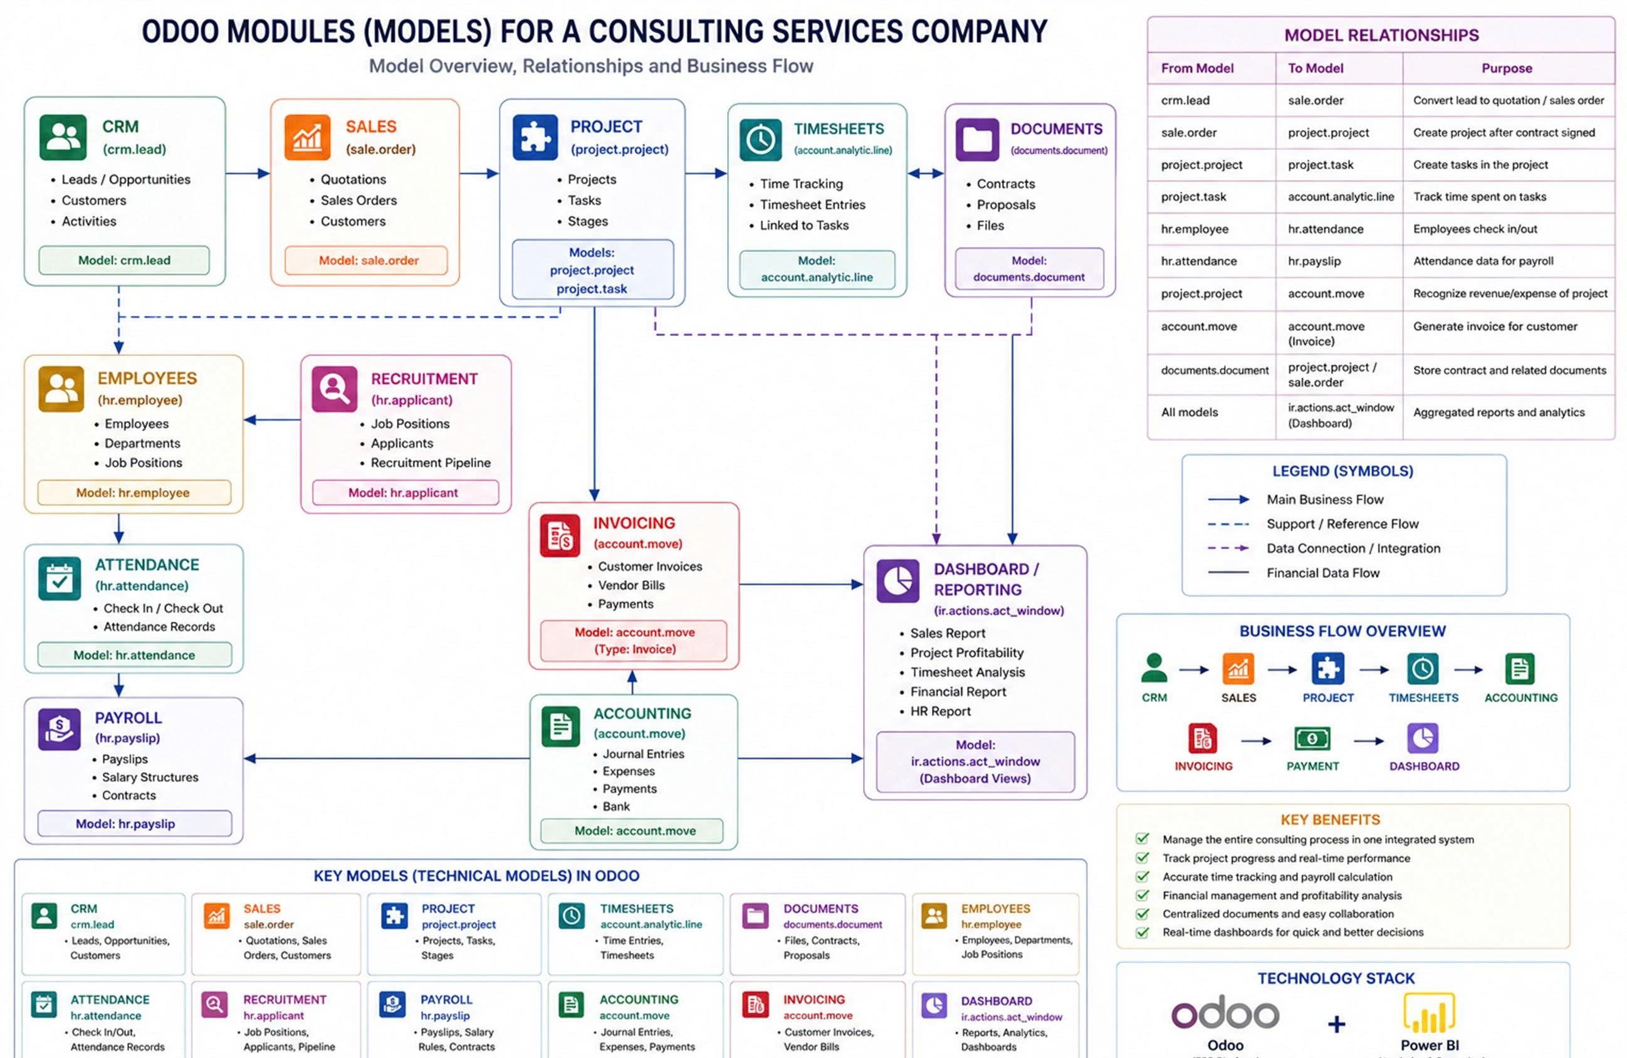
Figure 5. Odoo Modules (Models) For A Consulting Service Company

3.3.3. CRM Module
Create Opportunity
- Go to: CRM → Pipeline
- Click Create
- Enter:
  - Customer name
  - Opportunity name
- Click Save
Manage Pipeline
- Move opportunities through stages:
  - Lead → Qualified → Proposal → Won

3.3.4. Sales Module
Create Quotation
- From CRM, click New Quotation
- Add service/product
- Click Save
Confirm Sales Order
- Click Confirm
- The system will automatically:
  - Create Sales Order
  - Generate Project (if service is configured)

3.3.5. Project Module
Access Project
- Go to: Project → Projects
- Open the project created from Sales
Manage Tasks
- Tasks are organized into stages:
  - To Do → In Progress → Review → Done
Update Task Progress
- Drag tasks between stages to update status

3.3.6. Timesheet Module
Record Working Time
- Go to: Timesheets
- Click Add a line
- Enter:
  - Project
  - Task
  - Hours worked
  - Description
Purpose
- Track employee working time
- Calculate project cost
- Support billing

3.3.7. Accounting Module
Create Invoice
- Go to: Sales → Orders
- Open Sales Order
- Click Create Invoice
- Select:
  - Based on Timesheets
Confirm Invoice
- Click Post (Đã vào sổ)

Register Payment
- Click Register Payment (Thanh toán)
- Enter full amount
- Click Confirm
Payment Status
- Draft → Not confirmed
- In Payment → Partially paid
- Paid → Fully paid

3.3.8. Integrated Workflow Explanation
1. CRM: Customer information is recorded.
CRM → SALES
Connection between the customer prospecting stage and the contract closing stage.
Operation: In the Lead/Opportunity detail interface, click the New Quotation button.
Integration Results:
- The system automatically links the Quotation ID to the corresponding CRM record.
- All customer information and communication history from the CRM are inherited into the Quotation.
- Help the sales department track the conversion rate from potential customers to actual sales orders.
2. SALES: Quotation and contract are created.
SALES → PROJECT
Connection between closing a sales order and starting project execution.
Required Condition: The product in the Sales Order must be of the Service type, and the Create on Order setting must be configured as Project & Task.
Operation: Click Confirm on the Sales Order (SO).
Integration Results:
- Odoo automatically creates a new Project (or adds tasks to an existing project).
- Each service line in the SO becomes a Task within that project.
- A Smart Button appears on the SO, allowing direct access to the Project.
3. PROJECT: Project and tasks are automatically generated.
4. Task Management: Tasks are assigned and tracked.
PROJECT → TIMESHEET
Connection between task execution and time cost recording.
Operation: Employees open the assigned Task, select the Timesheets tab, and enter their working hours.
Integration Results:
- Working hour data is aggregated back into the Project to calculate the completion percentage.
- The system automatically calculates labor cost values based on the salary configuration assigned to each employee.
- Help project managers determine whether the project is operating at a profit or loss in terms of time compared to the original plan.
5. TIMESHEET: Employees record working hours.
6. Invoice: Invoice is generated based on timesheets.
7. ACCOUNTING: Customer payment is recorded.
TIMESHEET → ACCOUNTING
Connection between work results and actual revenue generation.
Required Condition: The service product in the original Sales Order (SO) must have the invoicing policy set to Based on Timesheets.
Operation: In the Sales Order, click Create Invoice.
Integration Results:
- Odoo automatically scans all recorded Timesheet hours that have not yet been invoiced and includes them in the invoice.
- The system posts revenue to the appropriate accounting accounts configured in the system.
- Ensures customers are billed accurately based on the actual working time spent by the consulting team.

3.3.9. Key Benefits
- Centralized data management
- Real-time information updates
- Improved collaboration between departments
- Reduced manual work and errors
- Accurate financial tracking

3.3.10. Conclusion
The Odoo ERP system helps Nova Consulting Company integrate all business processes into a unified platform. It improves efficiency, transparency, and supports better decision-making.

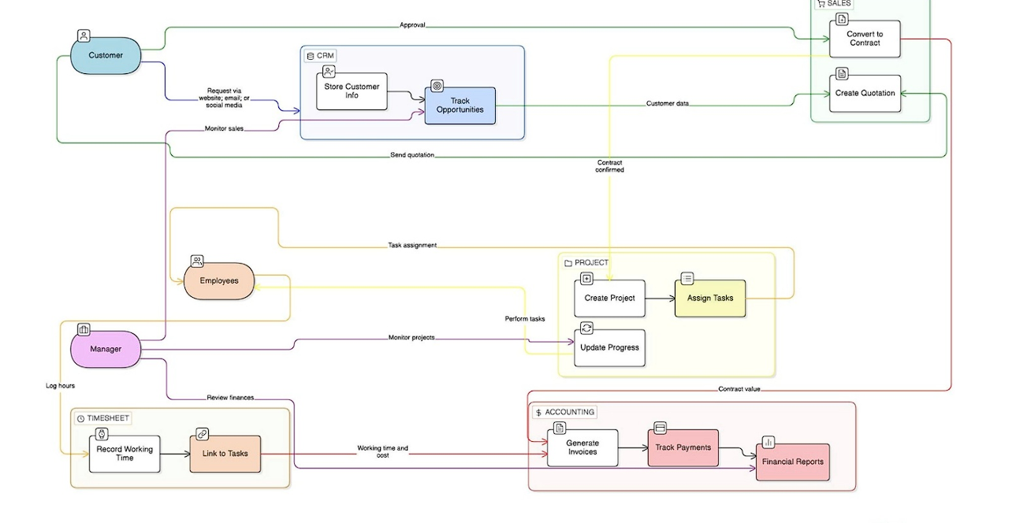
3.4. Detailed Business Process Flow Diagram
Figure 6. Integrated Business Process Workflow Using Odoo ERP
The diagram above illustrates the closed-loop operational process at Nova Consulting, which is divided into four main stages:
Stage 1 (Approach): Converting Demand into Opportunities
The process begins from the Customer through multi-channel touchpoints (website, email, social media).
- CRM Module: Not merely a storage system, CRM acts as a data filtering tool. Customer information is systematized so that the sales team can perform nurturing activities.
- Track Opportunities: At this stage, opportunities are classified based on their probability of success. Data from this step is a crucial foundation for revenue forecasting and understanding actual customer needs before proposing specific solutions.
Stage 2 (Commitment): Establishing Legal and Financial Agreements
This is a critical transition point between potential and actual business.
- Sales Module: Responsible for converting discussions from the CRM stage into concrete figures through Quotations. These quotations include details of services, pricing, and payment terms.
- Approval and Conversion (Convert to Contract): Two-way interaction (approval) from the customer is required. Once approved, the system automatically converts the quotation into a Contract. This ensures data consistency and avoids manual data entry errors between departments.
Stage 3 (Execution): Project Operation and Productivity Optimization
Once the contract is effective, the information flow is transferred to the operations department.
- Project Module: The system automatically creates projects based on the committed items in the contract. Task assignment is conducted transparently, helping employees clearly understand their roles and deadlines.
- Employee Collaboration: Employees not only execute tasks but also act as data input sources by updating progress.
- Timesheet Module: This acts as a “bridge” between operations and finance. Recording working time and linking it directly to tasks enables the company to accurately measure actual labor costs compared to the planned budget.
Stage 4 (Finance): Cash Flow Control and Management Performance
This stage completes the cycle by converting work efforts into economic value.
- Accounting Module:
- Generate Invoices: Invoices are created based on two data sources: contract value (from Sales) and actual workload (from Timesheet).
- Track Payments: Ensures cash flow is collected on time from customers.
- Role of Manager: The manager plays an overall monitoring role through dashboards.
- Monitor sales from CRM/Sales.
- Track progress and performance from Project/Timesheet.
- Evaluate financial health through Financial Reports such as P&L (Profit and Loss Statement), supporting strategic decision-making for the next phase.
Core Value of the Process
The strength of this model lies in data integrity. A single input from the customer flows seamlessly across departments without disruption, enabling Nova Consulting to optimize resources, minimize errors, and enhance customer experience through professionalism at every stage of service delivery.

IV. DATA ANALYSIS AND MANAGEMENT REPORTING

4.1. Dashboard Design

4.1.1. Executive Dashboard
Objective: Designed for the CEO/Leadership to gain an overview of Revenue, Profit, and Receivables Risk.
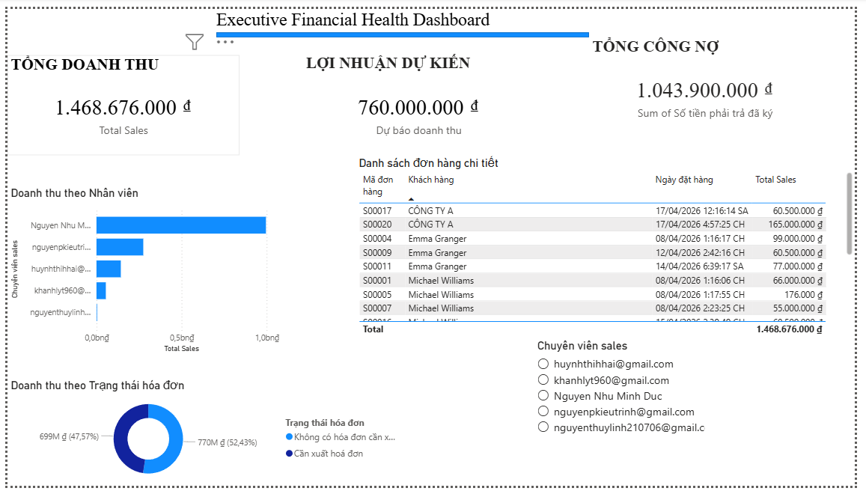
Figure 7. Executive Financial Health Dashboard
The system tracks three indicators representing stages of the cash flow:
- Total Revenue (1,468,676,000 VND): The actual contract value from confirmed sales orders (Sale Order).
- Revenue Forecast (760,000,000 VND): Potential revenue based on the CRM pipeline, helping the business proactively plan short-term finances.
- Total Receivables (1,043,900,000 VND): Outstanding amounts from invoices (Invoices), warning managers about cash flow risks.
Detailed Performance Analysis
- Revenue by Employee:
Evaluates the capability of the consulting team. The data shows that employee Nguyen Nhu Minh Duc is leading, reflecting effective closing skills and customer exploitation.
- Invoice Status:
Identifies that 52.43% of orders are in the “To Invoice” status. This is a bottleneck that needs to be addressed to formalize revenue in the accounting records.
- Detailed Sales Order List:
Allows drill-down capability. For example, identifying that the sudden revenue increase on April 17 comes from large orders such as S00021 from customer Company B.
Management Recommendations
- Accelerate debt collection:
Focus on handling receivables from major customers (Company A, Michael Williams) to optimize liquidity.
- Optimize the invoicing process:
Review and accelerate invoicing to shorten the cash collection cycle and recognize actual revenue more quickly.

4.1.2. Department Manager Dashboard
Objective: Designed for the Sales Manager to monitor which service categories perform best and track revenue growth over time.
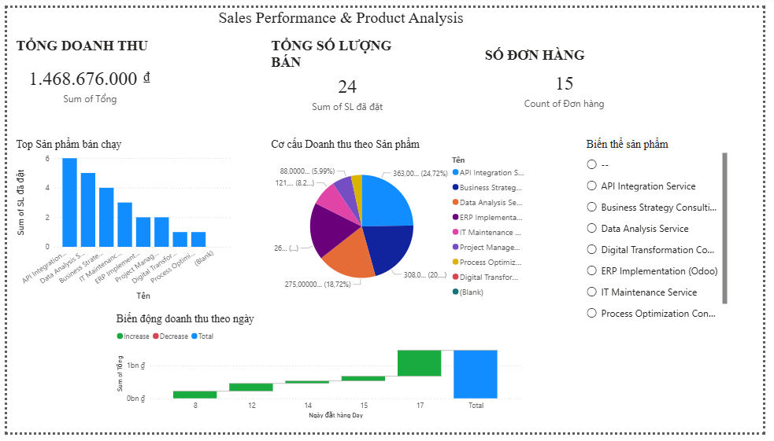
Figure 8. Executive Financial Health Dashboard
The Dashboard focuses on three figures reflecting the intensity of business activities:
- Total Revenue (1,468,676,000 VND): The ultimate measure of the effectiveness of all sales campaigns.
- Total Quantity Sold (24): Reflects market demand and the coverage of solution packages.
- Number of Orders (15): Tracks transaction frequency, helping calculate the average order value to optimize upselling strategies.
Product Portfolio and Trend Analysis
- Top-selling products: Identifies core services such as API Integration and Data Analysis. This serves as a basis for focusing technical resources and prioritizing marketing budgets.
- Revenue structure: Analyzes the contribution ratio of each service. Helps identify products that generate high revenue despite low sales volume (such as ERP Implementation) to balance the investment portfolio.
- Revenue trend by day: Tracks growth in real time. The surge on the 17th allows managers to trace successful activities and replicate effective practices.
Management Recommendations
- Prioritize “star” products: Focus resources on services with high closing frequency to optimize profitability.
- Forecast peak periods: Use time-based trend data to proactively allocate personnel, avoiding localized overload during sales spikes.
- Refine the portfolio: Use the variant slicer to capture customer trends, helping adjust services to better match actual market demand.

4.1.3. Operations/Project Management Dashboard
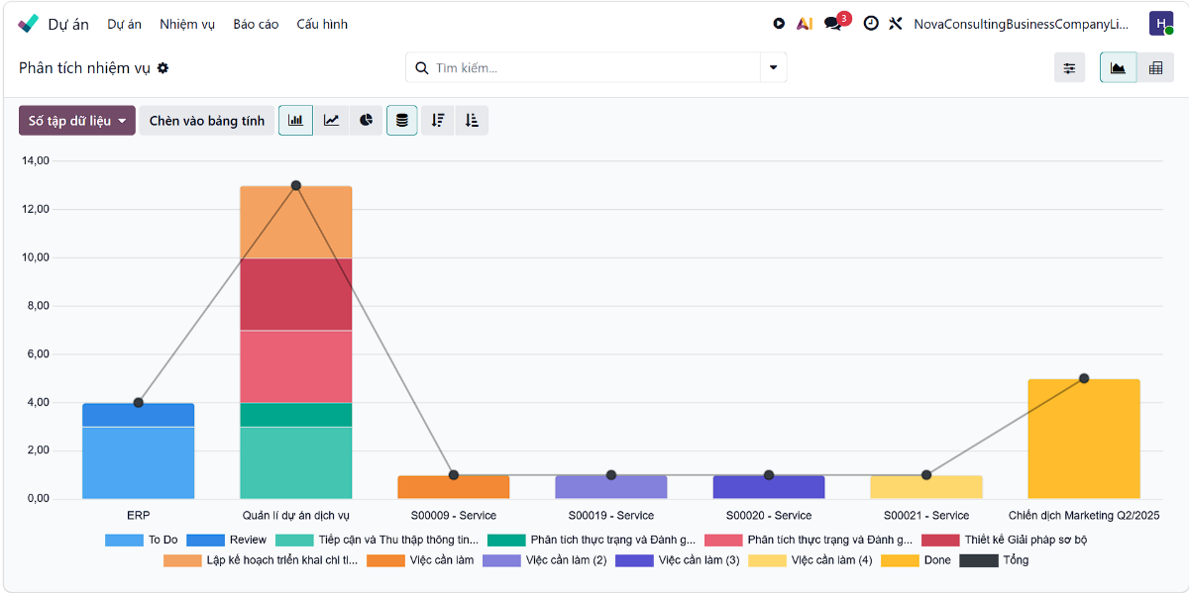
Objective: Designed for Project Managers (PMs) to monitor ongoing tasks, work status, and control employee timesheets.

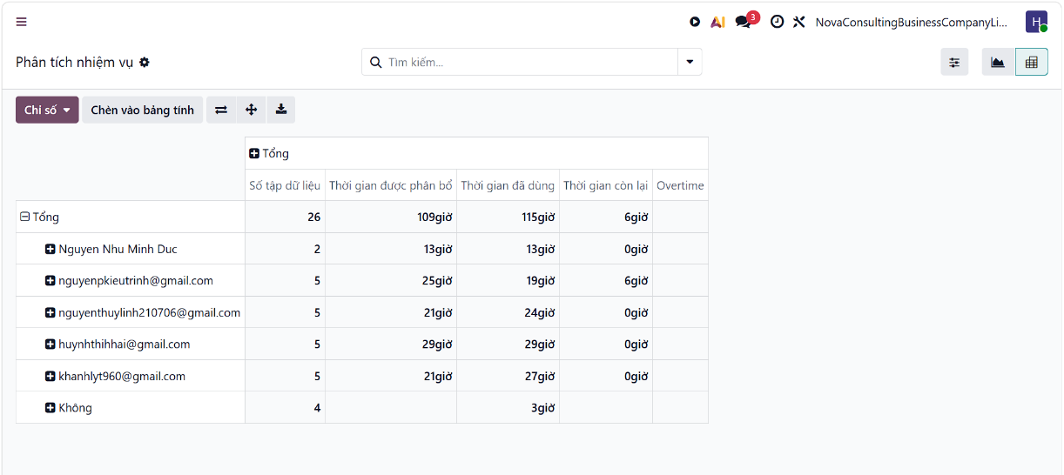
Figure 9. Project Task Analysis Dashboard in Odoo
Figure 10. Employee Task and Time Allocation Analysis in Odoo

In this section, the selected metrics aim to control project scale and resources:
- Total number of tasks (26): Reflects the current workload, helping managers assess the overall execution volume to allocate resources appropriately.
- Allocated time (109 hours): Serves as the “time budget” baseline for comparison with actual performance.
- Actual time spent (115 hours): Indicates execution efficiency. The fact that actual time exceeds allocated time signals the need for intervention to prevent delays or resource waste.
Detailed Analysis of Progress and Productivity
- Tasks by stage chart: Helps identify bottlenecks. For example, the “Service Project Management” project currently has the highest workload concentration, particularly in the Review and Planning stages, requiring priority attention.
- Individual performance table: Helps managers identify overload (overtime) or underutilization.
Management Recommendations
- Optimize resource allocation: Review and rebalance workloads of overloaded staff to prevent burnout.
- Monitor key projects: Focus resources on projects with high task volumes to ensure critical milestones are met.
- Adjust baselines: Update time estimates for future projects based on actual data to improve accuracy in pricing and planning.

4.2. List of Key Reports

4.2.1. Invoice Analysis Report
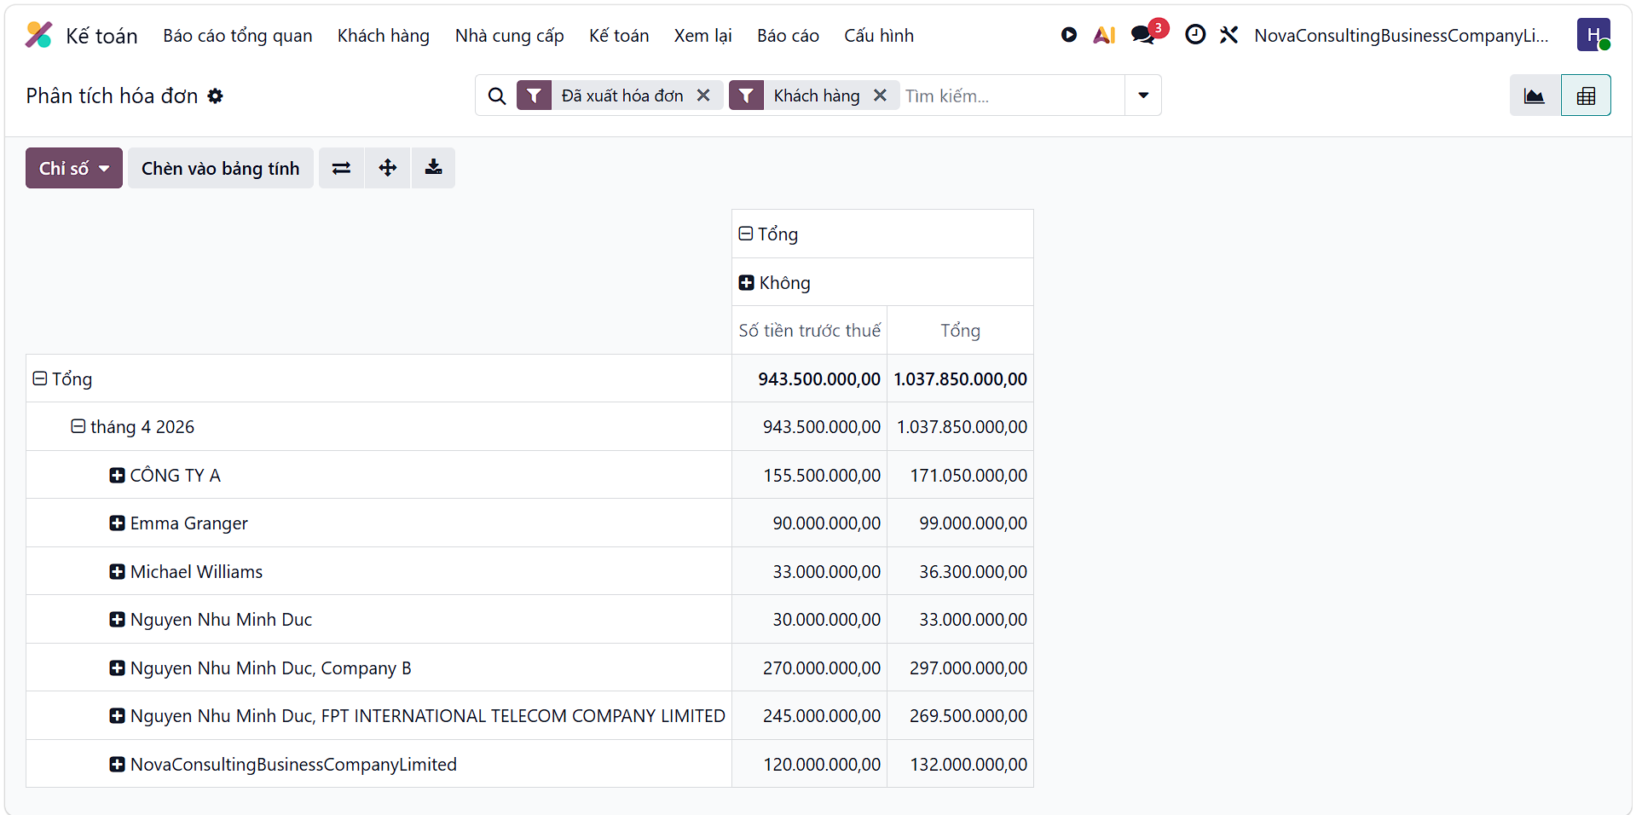
Figure 11. Invoice Analysis Report

This report provides an overview of business results in April 2026:
- Net revenue (amount before tax): reached 943,500,000 VND. This is the actual figure reflecting the sales or service performance of the enterprise during the period.
- Total invoice value (including tax): reached 1,037,850,000 VND. This is the amount that the accounting department needs to track for collection from customers. The difference (94,350,000 VND) helps managers understand the VAT payable obligation.
The invoice analysis report on Odoo helps managers identify strategic customers such as Company B or FPT to optimize customer care resources, while also assessing risks to timely expand the customer base. This is also an important basis for controlling receivables, urging capital recovery, and ensuring financial transparency between departments. From this actual data, leaders can make accurate forecasting decisions on human resources, business plans, and maintain solid legal records for tax or fundraising activities.

4.2.2. Project Profitability Report
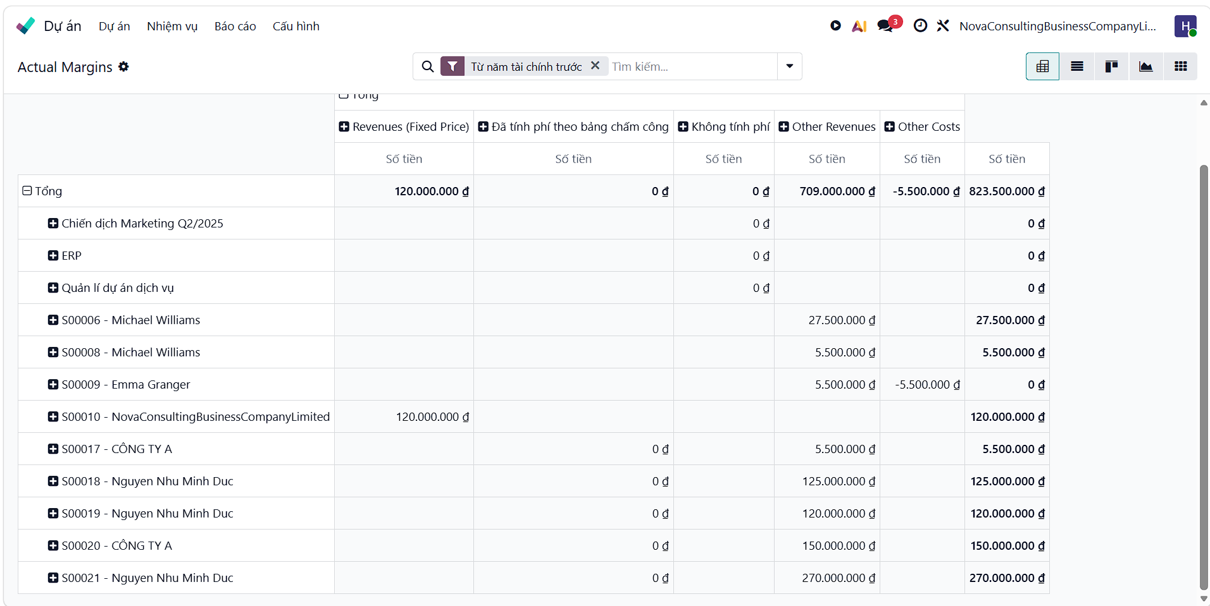
Figure 12. Project Profitability Report
The report provides a detailed view of the profitability performance of projects as of April 2026:
- Total actual revenue: reached 823,500,000 VND. This is an important indicator reflecting the project execution capability and the actual value that the enterprise obtains after cost adjustments.
- Revenue structure: Includes fixed revenue (120,000,000 VND) and other service revenues (709,000,000 VND). Monitoring this helps managers evaluate the level of diversification in the company’s service delivery model.
- Control of additional costs: The other cost (-5,500,000 VND) in project S00009 needs to be noted to reconcile revenue deductions or unplanned expenses, ensuring that target profit is not eroded.
The report helps identify efficient projects (S00021, S00020) to focus resources and reassess low-profit projects. This serves as a basis to optimize pricing, control cost risks, and ensure financial transparency between operations and accounting. From this, management can allocate human resources, improve quotations, and build a strong financial capability profile to work with major partners.

4.2.3. Employee Timesheet Report
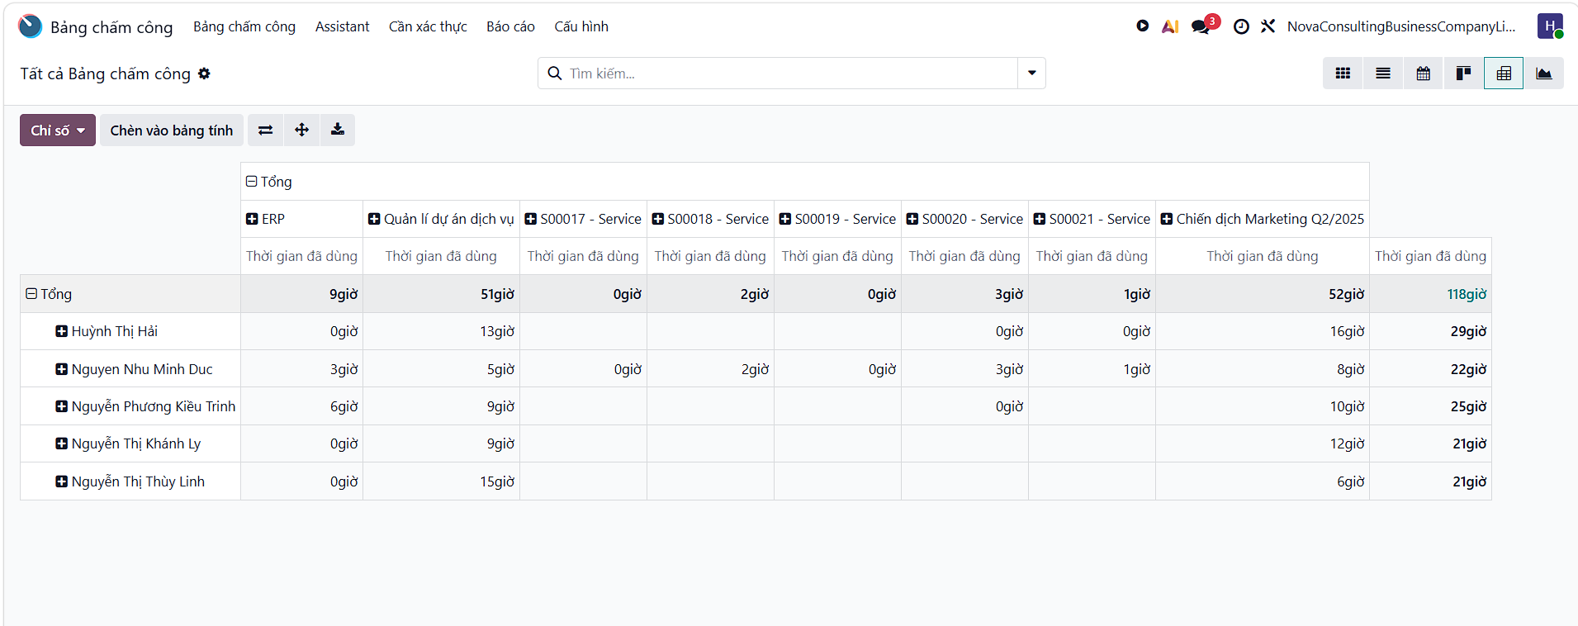
Figure 13. Employee Timesheet Report
The report provides an overview of the utilization of workforce time up to the present:
- Total time used: reached 118 hours. This is a quantitative indicator reflecting the actual workload completed by the team across all projects.
- Allocation by project: The largest amount of time is concentrated on the Q2/2025 Marketing Campaign (52 hours) and Service Project Management (51 hours). This shows that the company’s operational focus is currently concentrated on market promotion activities and customer service delivery.
The timesheet report helps managers monitor resource allocation and balance employee workloads. This serves as a basis for reallocating personnel across projects (ERP, S00017–S00021) to optimize productivity. This data also supports accurate payroll calculation, ensures transparency in labor costs, and improves the ability to estimate implementation time for future contracts.

4.2.4. Revenue Forecast Report
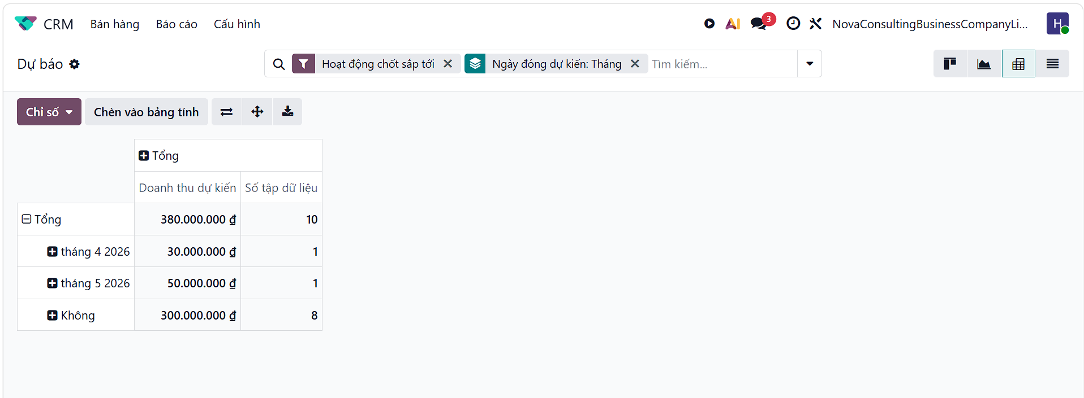
Figure 14. Revenue Forecast Report
This report provides an overview of expected revenue and the health of the sales pipeline:
- Total expected revenue: reached 380,000,000 VND from 10 business opportunities (dataset size). This is the target figure that the sales team is aiming for to ensure sustainable business growth.
- Time-based progress: Expected revenue is projected in April (30,000,000 VND) and May (50,000,000 VND). This allocation helps managers evaluate the expected short-term cash inflow.
- Potential backlog: Up to 300,000,000 VND (from 8 opportunities) is currently in the status of “No” expected closing date. This is a point of concern as it reflects sales opportunities that have not been actively pushed forward or lack a clear closing roadmap.
The forecast report helps managers proactively prepare resources and evaluate the productivity of the sales team based on existing opportunities. It serves as a basis to optimize sales strategies and urge the sales department to convert potential opportunities into actual revenue. From this, the company can develop accurate budgeting plans, minimize cash flow risks, and build a long-term development roadmap based on quantitative data.

4.2.5. Overdue Receivables Report
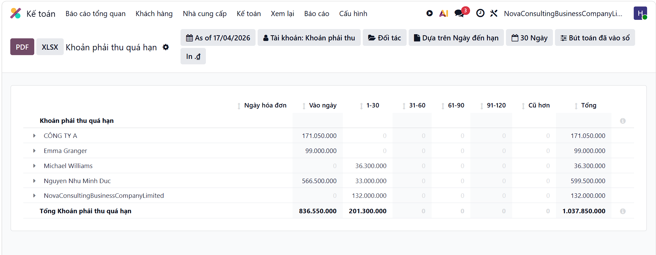
Figure 15. Overdue Receivables Report
This report provides a direct view of the outstanding debt situation and the quality of the company’s receivables:
- Total receivables: reached 1,037,850,000 VND. This is the total amount of the company’s capital currently occupied by customers, reflecting pressure on current cash flow.
- Aging classification: Most of the debt falls into the “Current” group (836,550,000 VND) and the 1–30 days group (201,300,000 VND). The concentration of debt in newly incurred groups indicates that receivables are still under control but require the initiation of follow-up actions.
- Key debtors: Customer Nguyen Nhu Minh Duc has the largest outstanding balance at nearly 600 million VND, followed by Company A (171 million VND). These are the entities that the accounting and sales departments need to closely monitor to ensure recoverability.
The receivables aging report helps managers identify liquidity risks to proactively manage cash flow and avoid financial disruption. It serves as a basis to optimize credit policies, tighten limits for slow-paying customers, and prioritize the collection of large debts. This data also supports accurate provisioning, protects financial stability, and ensures transparency in receivables management for partners and executive management.

4.3. Data Analysis and Recommendations

4.3.1. Actual Data Analysis (April 2026)
Based on the provided data, the key financial and operational metrics are as follows:
- Invoiced Revenue: 943,500,000 VND (excluding VAT) / 1,037,850,000 VND (including VAT).
- Actual Project Revenue (Actual Margins): 823,500,000 VND.
- Total Overdue Receivables: 1,037,850,000 VND (equal to the total invoiced amount).
- Total Timesheet Hours: 118 hours.
- Forecast Revenue (CRM): 380,000,000 VND.

4.3.2. Identification of Key Issues
- Discrepancy between Invoiced Revenue and Actual Profit:
There is a gap of approximately 120 million VND between invoiced revenue (943 million VND) and project-based revenue (823 million VND). This indicates that some invoiced revenue has not yet been fully recognized in project values, or there are unaligned revenue adjustments.
- Uneven Project Performance:
Project S00009 is currently operating at a loss (-5.5 million VND). Meanwhile, a significant portion of time resources is concentrated on general activities such as “Marketing Campaign” and “Project Management” (accounting for over 80% of total hours), reducing the profit margins of core service projects.
- Bottleneck in Deal Closing:
Approximately 80% of forecast revenue in the CRM (300 million VND) has no expected closing date. While the sales team is generating opportunities, they are facing challenges in converting them into actual contracts.

4.3.3. Proposed Improvement Solutions
Financial & Receivables Management
- Prioritize debt collection:
Management should directly engage with major clients (e.g., Minh Duc, Company A) to recover at least 50% of outstanding receivables in the short term.
- Credit control policy:
Configure Odoo to automatically block new invoices or suspend services for customers with overdue balances exceeding 30 days.
Operations & Project Management
- Optimize timesheet allocation:
Review task categorization within project teams. Reduce time spent on general administrative work and reallocate resources to high-margin projects such as S00021 (270 million VND).
- Resolve abnormal costs:
Immediately review Project S00009 to determine whether the 5.5 million VND loss is due to external expenses or data entry errors, and correct it promptly to prevent recurrence.
Sales (CRM)
- Enforce data discipline:
Require sales staff to update the “Expected Closing Date” for all open opportunities.
- Accelerate sales funnel conversion:
Conduct review meetings for the 8 opportunities without closing dates to address issues related to pricing or solutions, aiming to convert the 300 million VND pipeline into actual revenue in the upcoming month.

V. EVALUATION AND RECOMMENDATIONS

5.1. System Evaluation

5.1.1. SWOT Analysis of the Odoo Solution for Service and Consulting Companies
Strengths:
- All-in-one system with strong integration of modules such as CRM, Sales, Projects, Timesheets, and Accounting, well-suited to service-based businesses.
- Highly modular, open-source architecture, allowing easy customization based on real business processes.
- Reasonable implementation and operating costs, especially suitable for small and medium-sized enterprises (SMEs).
- Excellent support for tracking billable hours, project profitability, and real-time dashboards.
- Large community and numerous implementation partners in Vietnam.
Weaknesses:
- The Community version requires technical expertise for deep customization and maintenance.
- The interface and workflows may initially be challenging for users unfamiliar with technology.
- Some advanced features (complex Payroll, detailed Planning) require upgrading to the paid Enterprise version.
- Initial user training time can be relatively long.
Opportunities:
- Strong digital transformation trend among service companies in Da Nang and across Vietnam.
- Easy system scalability as the business grows (adding modules such as HR, Website, eCommerce, etc.).
- Good integration with e-invoicing, banking systems, and Vietnamese accounting standards.
- Enhanced competitiveness through professional project management capabilities.
Threats:
- Competition from other ERP solutions such as Microsoft Dynamics 365, Fast, and SAP Business One.
- Resistance from employees when changing existing workflows.
- Risk of dependency on implementation partners if internal IT resources are lacking.
- Potential additional costs for maintenance and system upgrades.

5.1.2. Comparison Between Odoo and Another ERP Solution
Comparison Solution: Microsoft Dynamics 365 Business Central (a popular ERP for service enterprises)
Criteria | Odoo | Microsoft Dynamics 365 Business Central
Implementation Cost | Low (community version offers many free modules) | High (annual licensing fees)
Customization Capability | Very high (open source) | Moderate
Suitability for Service Businesses | Excellent (strong timesheet & project features) | Good
Ease of Use | Moderate (requires training) | Easier to use
Vietnam E-invoicing Integration | Good | Good
Total Cost of Ownership (TCO) | Low | High
Implementation Time | 2 – 6 months | 4 – 9 months
Table 1. Comparison Between Odoo and Microsoft Dynamics 365 Business CentraL
Comment:
Odoo stands out in terms of cost efficiency and flexibility, making it highly suitable for small and medium-sized service companies in Vietnam. Microsoft Dynamics 365 is more appropriate for larger enterprises requiring strong Microsoft ecosystem support and a more modern user interface.

5.1.3. Cost–Benefit Analysis (Estimated)
Estimated Implementation Costs for Odoo (for a company with 20–40 employees, implementing 6–8 core modules):
- Software (Enterprise): 20 – 60 million VND/year (depending on users and apps)
- Consulting, implementation & customization: 80 – 200 million VND
- Training & data migration: 15 – 40 million VND
- Maintenance & first-year support: 20 – 50 million VND
Total first-year cost: Approximately 150 – 350 million VND
(Can be lower if using the Community version with minimal customization)
Expected Benefits:
- Reduce 30–50% of manual work time (Timesheets, reporting, invoicing).
- Increase billable rate from 60–65% to 80–85%.
- Reduce data errors and improve cash flow through process automation.
- Save approximately 25–40% in operating costs after 12–18 months.
- Expected ROI: Achieved within 12–18 months.

5.1.4. Evaluation of Information Integration Efficiency
The implementation of Odoo significantly improves internal information flow:
- Reduced data duplication: All customer, project, timesheet, and invoice data are stored in a centralized database.
- Improved information flow: Real-time data updates across departments (Sales → Projects → Accounting).
- Faster decision-making: Management can instantly access dashboards on revenue, project profitability, and utilization rates.
- Reduced input errors: Automated data flow from Leads to Projects and Invoices reduces 70–80% of manual entry errors.
- Overall improvement: Transition from fragmented systems to a unified management platform, significantly enhancing communication efficiency and reducing operational delays.

5.2. Development Recommendations

5.2.1. Implementation Roadmap in Three Phases
The implementation of Odoo at Nova Consulting should follow a phased (rolling) approach to ensure stability for an organization of approximately 55 employees.
- Phase 1: Focus on digitalizing front-office operations using CRM and Sales modules. The primary objective is to migrate all customer data from fragmented Excel files into a centralized PostgreSQL database, enabling the 10-member sales team to track the sales pipeline transparently.
- Phase 2: Expand into core operations by implementing Project and Timesheet modules. This is a critical transition for 20 consultants and 8 project managers, eliminating manual tracking via Google Sheets. Real-time time tracking at the task level ensures accurate performance measurement and resolves process fragmentation issues.
- Phase 3: Complete the financial ecosystem through the Accounting module. Data from quotations and timesheets automatically flows into accounting for invoicing and financial reporting without re-entry. After stabilization, the system will be evaluated and dashboards refined to support data-driven decision-making by top management.

5.2.2. Risk Management and Future Expansion Architecture
During implementation, the greatest risk is employee resistance to changes in working habits. To mitigate this, the company should develop a strong internal communication strategy combined with role-based training programs.
From a technical perspective, data migration risks must be controlled through strict validation and reconciliation processes before go-live.
For long-term scalability, the system should be designed with high scalability and availability. Odoo allows flexible infrastructure upgrades as project volume increases without disrupting operations. Additionally, a disaster recovery strategy with automated daily backups across independent data centers ensures business continuity.
In the future, integrating advanced technologies such as Artificial Intelligence (AI) for revenue forecasting and Business Intelligence (BI) for deep customer behavior analysis will be key to enhancing competitiveness. Additional modules such as Recruitment and Helpdesk should also be considered for comprehensive HR and customer service support.

5.3. Lessons Learned

5.3.1. The Role of MIS and Expert Skills in Digital Transformation
The ERP implementation at Nova Consulting demonstrates that Management Information Systems (MIS) are not merely software tools but the backbone of organizational management. MIS acts as a bridge to eliminate “information silos” between Sales, Consulting, and Accounting departments.
For MIS professionals, the key lesson is the integration of process thinking and technical expertise. Experts must not only understand data architecture (e.g., PostgreSQL) and security protocols (HTTPS) but also possess strong business analysis skills to translate real-world requirements into system configurations. Change management and consulting skills are critical to gaining user trust.

5.3.2. Lessons on Integration and System Sustainability
The success of an ERP system depends on interoperability and data consistency. At Nova Consulting, a key lesson is that data should be entered only once at the initial stage and then seamlessly propagated throughout subsequent processes.
This approach saves time, eliminates manual entry errors, and ensures that accounting data fully aligns with sales commitments.
Finally, system reliability must be a top priority in architectural design. While cloud deployment offers flexibility for remote work, it requires multi-layer security mechanisms, from user authentication to data encryption.
Building a system that is both functionally powerful and secure provides a strong foundation for sustainable digital transformation in the modern era.

CONCLUSION
Following a period of intensive research, business analysis, and practical implementation on the Odoo platform, the project has fully achieved its initial objectives: constructing a comprehensive and integrated management system for NovaConsultingBusinessCompanyLimited. The Odoo solution deployed by our team has proven its capability to thoroughly resolve the "information silo" problem, establishing seamless and instantaneous connectivity between key departments such as Sales, Project Management, and Finance & Accounting.
The standardization of workflows through the CRM, Sales, Project, and Accounting modules not only minimizes human errors but also provides management with a "panoramic view" of financial health and personnel performance via a real-time management reporting system (Dashboard). Although there is still room for further development—such as integrating deep AI algorithms to optimize resource allocation or expanding specific localization features—the project has confirmed the high practicality and flexible adaptability of ERP in a volatile business environment.
Through this project, our team has not only accumulated purely technical skills but, more importantly, formed systems thinking and the ability to view technology through the lens of solving business problems. These are vital prerequisites for us to continue researching and contributing to the digital transformation process of enterprises in the future. The team hopes that the results of this project will serve as a vivid testament to the application of technology in creating value and elevating the position of Vietnamese enterprises.

REFERENCES
[1]. Odoo S.A. (2025). Odoo Documentation - Official User Guide. Retrieved from https://www.odoo.com/documentation/17.0/
[2]. Odoo (2024). Odoo for Service Companies - Best Practices. Odoo Official Website. https://www.odoo-bs.com/odoo-for-service-companies
[3]. Davenport, T. H. (1998). Putting the Enterprise into the Enterprise System. Harvard Business Review. https://hbr.org/1998/07/putting-the-enterprise-into-the-enterprise-system
[4]. Monk, E., & Wagner, B. (2012). Concepts in Enterprise Resource Planning (4th ed.). Cengage Learning. https://www.cengage.com/c/concepts-in-enterprise-resource-planning-4e-monk-wagner/9781111820398/
[5]. Odoo Community Association. (2025). Odoo Implementation Methodology for Service Industry. https://www.odoo.com/web/content/17936384
[6]. Laudon, K. C., & Laudon, J. P. (2020). Management Information Systems: Managing the Digital Firm (17th ed.). Pearson. https://www.pearson.com/en-us/subject-catalog/p/management-information-systems-managing-the-digital-firm/P200000001392/9780136971542
[7]. Deloitte. (2024). ERP Trends 2025: Focus on Cloud and AI Integration. https://www.deloitte.com/us/en/what-we-do/capabilities/applied-artificial-intelligence/articles/how-erp-is-evolving-in-agentic-ai-era.html
[8]. Oracle. (2023). ERP for Professional Services Industry - White Paper. https://www.oracle.com/a/ocom/docs/oracle-industry-playbook-professional-services.pdf

